Assignment 3.2

Max-temp.txt file

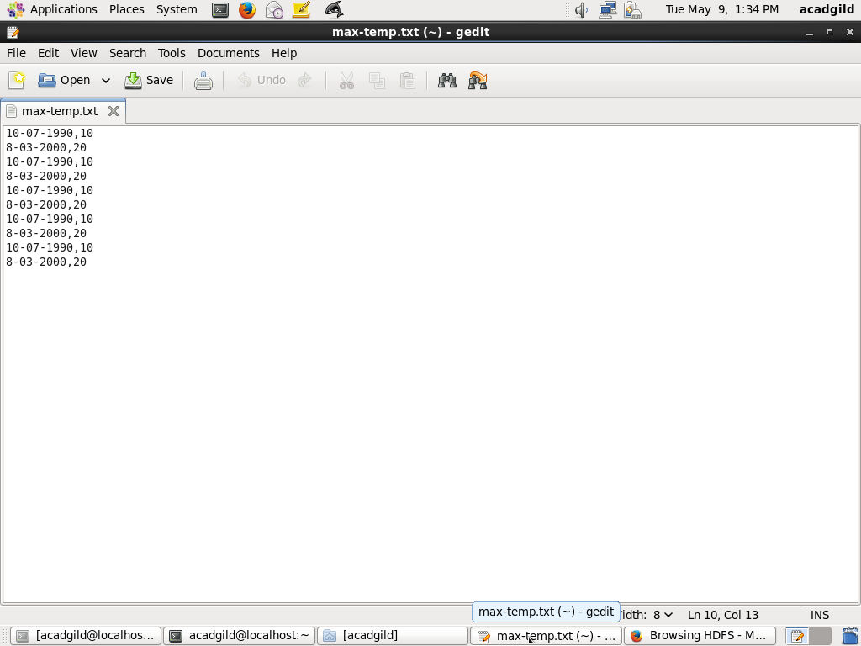

Commands to put the file from local to hdfs and giving rwx to group and only r to others

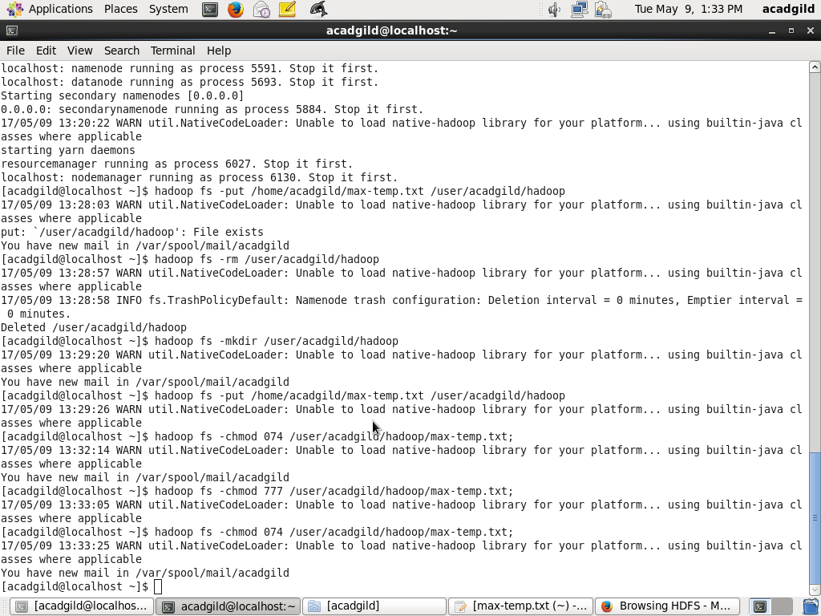

File in hdfs

